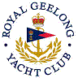 | Royal Geelong Yacht Club Inc.  Est 1859
Trophy Deed of Gift.

Trophy: | Licence Victualler’s Trophy
Presented by:
Date:
For:
Remarks / Revisions | Awarded for Event 14 in Season 1948-1949 for “B” Class, and Won (somehow) by Penola.  Trophy would belong to Geoff Wood.

